Zoe Bobelo
ST10530562 WEDE5112
PART 1 -POE

Table of Contents
1. TARGET ORGANISATION 2
1.1 Selected Organisation: 2
Target Audience: 2
Project Goals: 2
KPI’s to measure success 2
Specific goals are to: 2
2. LEXHAPHOTOGRAPHY WEBSITE 4
Organisation Overview 4
Mission Statement: 4
Vision Statement: 4
Target Audience: 4
2. Website Goals and Objectives 4
Specific objectives include: 4
Key Performance Indicators (KPIs): 5
Proposed Website Features and Functionality 5
Design and User Experience Considerations 5
Colour scheme: 5
Typography: 5
Low fidelity –wireframe 6
Technical Requirements 6
Platform: 7
Integrations: 7
Timeline and Milestones Week 1-2: 7
Budget Estimate 7
3.COMPETITOR ANALYSIS / INSPIRATION RESEARCH 8
3.1 LERISSA KEMP PHOTOGRAPHY 8
3.2 ERIK FORSTER PHOTOGRAPHY 9
4.WEBSITE STRUCTURE & PLANNING 10
SITE MAP: 10
4. REFERENCES 12
AI DECLARATION 13

1. TARGET ORGANISATION

1.1 Selected Organisation:

Small Business
For this project, I have selected the Small Business option as it meets all the requirements for WEDE5020. The chosen organisation is LEXHAPHOTOGRAPHY, a real, operating small business owned by Liliso Ntloko. The business currently operates in Komani, Queenstown in the Eastern Cape and Sandton, Gauteng, and offers photography services including Matric Dance shoots, Nature photography, and Model Shoots.

Currently, LEXHAPHOTOGRAPHY has no official website and relies solely on WhatsApp and Instagram to secure clients, which limits growth and appears unprofessional to corporate and wedding clients. A small business of this nature requires an affordable, professional website to compete with larger studios, build trust, and centralise its portfolio, which makes it a perfect candidate for this project.

Target Audience:
Age 16-19 matric dancers, 18-25 aspiring models, 25-45 families. Middle-income, active on Instagram/WhatsApp/TikTok, based in Komani and Sandton.

Project Goals:
The primary goal of this project is to create a functional and visually appealing website that meets the needs of LEXHAPHOTOGRAPHY. The website will be easy to navigate, informative, and engaging.

KPI’s to measure success
- KPI 1: Number of enquiry form submissions - target 10 per month
- KPI 2: Time spent on Image Gallery page - target >2 mins
- KPI 3: Clicks to Instagram/WhatsApp
- KPI 4: Bounce rate <60%

Specific goals are to:
a) Make it easy for clients to view the entire portfolio (Nature, Matric Dance, Model Shoots) in one central place.
b) Allow clients to enquire and book through a dedicated enquiry form instead of relying only on social media DMs.
c) Provide clear and professional contact information, including two locations (Eastern Cape and Sandton), operating hours, and official contact details.
d) Create a luxury brand identity using charcoal #2B2B2B and gold #D4AF37 to match the photography style and attract higher-paying clients.

Mission: To capture authentic and timeless moments with a clean, luxury charcoal and gold aesthetic, making every client feel confident and distinguished.
Vision: To become the leading youth photography brand in SA for matric dance and model portfolio photography by 2027.

2. LEXHAPHOTOGRAPHY WEBSITE

Organisation Overview

LEXHAPHOTOGRAPHY is a small business and creative service based in Komani, Queenstown in the Eastern Cape and Sandton, Gauteng, South Africa. The organisation specialises in professional photography services including Matric Dance shoots, Nature shoots, Model Shoots, Portraits, and Family shoots.

Mission Statement:
To capture authentic and timeless moments with a clean, luxury aesthetic, making every client feel confident and celebrated.
Vision Statement:
To become the leading youth photography brand in South Africa for Matric Dance and model portfolio photography by 2027.
Target Audience:
Primary audience is Grade 11-12 learners (16-19 years) seeking Matric Dance photography; secondary audience includes aspiring models (18-25 years) and families (25-45 years). The audience is middle-income, active on Instagram, TikTok, and WhatsApp, and based in the Eastern Cape and Gauteng.
Currently, the business operates primarily through Instagram and word of mouth. There is no existing website, which limits professional visibility and client conversion. A dedicated website is required to showcase the portfolio, establish credibility, and streamline the booking process.

2. Website Goals and Objectives

The primary goal of the website is to generate leads and increase bookings by 40% within 12 months.

Specific objectives include:
- Showcase a professional portfolio to build brand credibility.
- Enable online quote requests and booking enquiries via a dedicated form.
- Increase brand awareness and website traffic through Search Engine Optimisation (SEO).
- Drive traffic to Instagram and reduce administrative enquiries via WhatsApp.

Key Performance Indicators (KPIs):
- Enquiry form submissions (target 10 per month)
- average time spent on Image Gallery page (target >2 minutes)
- number of clicks to Instagram/WhatsApp, and bounce rate (<60%).

Proposed Website Features and Functionality

The proposed website will include five core pages: Homepage with hero image and call-to-action, About Us with photographer biography and style, Image Gallery with categorised portfolios for Matric Dance, Nature, Model, Portraits and Family shoots, Enquiry Page with form for shoot type, preferred date and location, and Contact Page with phone, email and embedded Google Map. Additional features include a testimonials section, FAQ section, and social media integration.

Design and User Experience Considerations

The design will be clean, minimal, and image-focused to ensure photography remains central.
Colour scheme: charcoal #2B2B2B for header and footer with thin gold #D4AF37 2px border, body #FFFFFF, text #000000.
Typography:
Poppins Bold for headings and Arial Regular 16px for body, with clear hierarchy. Layout will use CSS Flexbox for alignment and CSS Grid grid-template-columns: 150px 150px for four-window gallery tiles with object-fit: cover. User experience will prioritise mobile-first design, fast-loading images with lazy loading, sticky navigation, and clear calls-to-action such as "View Portfolio" and "Book a Shoot". Accessibility includes alt text for images. Low-fidelity wireframes for Homepage and Image Gallery are included as Figure

Low fidelity –wireframe

Untitled – FigJam

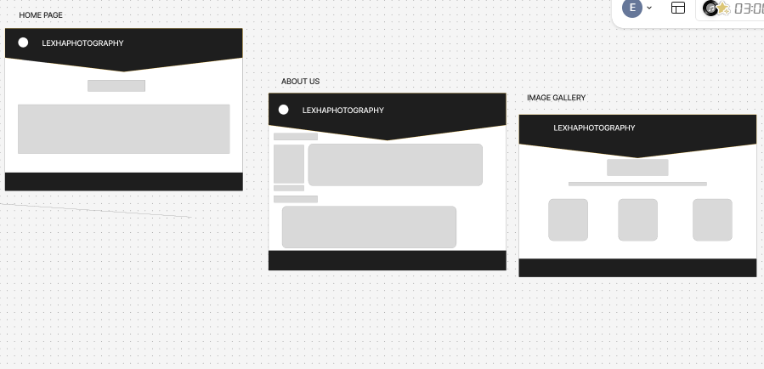

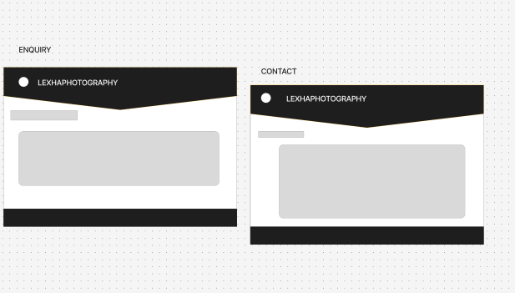

Technical Requirements
Platform:
Custom website developed using Visual Studio Code with HTML5 and CSS3, no external frameworks.
Integrations:
Instagram feed link, Google Maps, contact form with JavaScript validation. Security: HTTPS/SSL encryption. SEO: Image alt tags, meta descriptions, and Google Analytics 4 integration.7.

Timeline and Milestones Week 1-2:
Content gathering, portfolio assembly, and wireframe development.
Week 3-4: Design and development of five core pages.
Week 5: Testing, SEO optimisation, and mobile responsiveness checks.
Week 6: Website launch and client training.
Total estimated duration: 6 weeks

Budget Estimate
Design and Development: R22,000.00
Hosting and Domain for Year 1: R2,000.00
Stock Assets and Icons: R1,000.00
Testing, SEO, and Deployment: R1,500.00
Total: R26,500.003

3.COMPETITOR ANALYSIS / INSPIRATION RESEARCH

3.1 LERISSA KEMP PHOTOGRAPHY

I chose Lerissa Kemp Photography as inspiration because of its smooth and professional user journey. What I liked most is how the home page draws the user in. It uses a large, full-screen hero image with elegant white text over it that immediately shows the quality of her work and encourages scrolling. The quote and the "Get in touch" and "The Blog" sections are layered beautifully over the image. The entire website has a similar elegant, dark and luxury aesthetic to what I want to achieve for LEXHAPHOTOGRAPHY with my charcoal, gold and white theme.

For my website, I will integrate elements from her layout. From the home page, I will take inspiration for my own hero banner with centred welcoming text. From her About Us and Services page, I liked the clean three-column gallery showing Wedding, Portrait, and Product photography with ample white space. I will use a similar clean grid layout for my own gallery page and copy her idea of having bold headings on pages such as Contact Us to make them more visually appealing and professional. Lastly, I admired its simple navigation. The menu is clean and fixed at the top with only four main links, which makes it very easy for a client to find what they need. For LEXHAPHOTOGRAPHY, I will apply this same principle by keeping my navigation short and clear: Home, About Us, Image Gallery, Enquiry, Contact Us.

3.2 ERIK FORSTER PHOTOGRAPHY

I chose Erik Forster Photography as a major reference for LEXHAPHOTOGRAPHY because of its charcoal, dark theme and versatility. What stood out to me was the overall flow. Even though he showcases many different types of photography — from motocross to corporate, to food and fashion — the entire website still feels like one brand because he uses a consistent charcoal/dark background across all sections. This is exactly the versatile but consistent aesthetic I want to achieve.

I specifically liked the header. It is clean, simple and sticks to the top, with a creative logo on the left where the 'O' is a camera, and a simple menu on the right. It does not distract from the photos. I also liked how the home page draws you in with a large hero image with bold white text "Erik Forster Photography" over a dark background, which is powerful and welcoming.

The flow is very smooth. It scrolls from "About me" to "OUR GUARANTEE" to different genres like Food and Fashion in a story-like way. Each section uses a clean two-column layout — text on one side, big image on the other — with a small gold line under headings as an accent. For my website, I will integrate a similar layout for certain sections and use his dark charcoal background idea with white text for my header and footer to make my photos stand out, similar to my own charcoal #2B2B2B header/footer and gold #D4AF37 lining concept.

4.WEBSITE STRUCTURE & PLANNING

SITE MAP:

LEXHAPHOTOGRAPHY
|
|-- 01-home-page.html (Home)
| |-- Hero section - charcoal #2B2B2B header with gold #D4AF37 border + logo
| |-- Intro / Welcome text
| |-- Featured portfolio preview (MD, Nature, Model)
| |-- About preview + call-to-action
| +-- Book a Shoot section
|
|-- 02-about-us-page.html (About Us)
| |-- Owner story - Liliso Ntloko
| |-- Mission and Vision
| |-- Photographic style & equipment
| +-- Brand story - from phone camera to professional
|
|-- 03-image-gallery.html (Image Gallery)
| |-- Matric Dance - MD1.jpeg, MD2.jpeg, MD3.jpeg, MD4.jpeg
| |-- Nature photography - WhatsApp Images
| |-- Model Shoots - model pics.jpeg, model pics 2/3/4.jpeg
| +-- Grid layout - display: grid + object-fit: cover
|
|-- 05-enquiry-page.html (Enquiry)
| |-- Enquiry form - name, email, phone
| |-- Shoot type dropdown - Matric Dance, Nature, Model, Portrait, Family
| |-- Date picker + Location selector (Eastern Cape / Sandton)
| |-- FAQ - pricing, booking process, delivery times
| +-- Testimonials section
|
+-- 04-Contact-page.html (Contact Us)
|-- Contact information - phone, email
|-- 2 Locations - Komani, Queenstown + Sandton, Gauteng
|-- Business hours
|-- Embedded Google Map
|-- Contact form
+-- Social media integration - Instagram @lexhaphotography

4. REFERENCES

Instagram. (2026). LEXHAPHOTOGRAPHY (@lexhaphotography) • Instagram photos and videos. Available at: https://www.instagram.com/lexhaphotography/ [Accessed 6 August 2026].

Lerissa Kemp Photography. (2021). Photographer Johannesburg | Photography Gauteng | Lerissa Kemp. Available at: https://lerissakemp.co.za/ [Accessed 20 August 2026].

Rounding an image in CSS. (2026). Mimo.Org. https://mimo.org/glossary/css/rounding-an-image [Accessed 30 August 2026].

Supriya Shashivasan. (2021, March 23). How to build a Curved UI header. DEV Community. https://dev.to/omeal/how-to-build-a-curved-ui-header-51dm [Accessed 30 August 2026].

Warncke, S. (2020). Erik Forster Photography - For all your photographic needs. Available at: https://peach.co.za/ [Accessed 20 August 2026].

AI DECLARATION



